Thermal comfort in automobile cabin using equivalent and effective draft temperatureS

Prateek Bandi*, M.P. Maiya, Shaligram Tiwari

Department of Mechanical Engineeirng, Indian Institute of Technology Madras  
Chennai 600036, India

Corresponding author: bandiprateek4@gmail.com

**ABSTRACT**: Present work aims to study the thermal comfort of passengers in an automobile cabin under the effect of solar radiation. A subcompact car of 2.3 m3 cabin space is considered for this study. Three-dimensional transient cooling simulations of the cabin have been carried out using commercial solver ANSYS Fluent 18.1 for accurate prediction of temperature and velocity fields. Surface to surface (S2S) radiation model embedded within the solver has been employed to mimic the internal conditions of radiative heat transfer. Mixed radiative and convective boundary conditions have been imposed on the outer shell of the automobile cabin. RNG k- turbulence model with standard wall function is used to model the turbulent airflow inside the cabin. Solar load model built-in with the solver is used to calculate the solar heat flux in the cabin. Unsteady computations are carried out for 30 minutes of monitored time. Approximately 4.6 million unstructured tetrahedral finite volume cells have been used to capture the internal space and geometry of the cabin. Initial cabin temperature is taken as 50oC and the temperature of supply air is determined as a function of time with the help of a User Defined Function (UDF). Numerical results from present computations have been validated against experimental data reported in the literature. Temporal variation of temperatures at different levels, such as face, chest, and foot of the driver, have been illustrated. Approximately 5oC temperature difference is found to appear between face and foot level. Thermal comfort is estimated in terms of Equivalent Temperature (ET) and Effective Draft Temperature (EDT). The supply airflow rate has been kept constant and the direction of supply air flow is varied. Effect of flow direction on temperature distribution at various levels has been illustrated and comparison is made between ET and EDT values for different configurations at different points along the height of the driver and front passenger. It was observed that despite ET values being in the comfort zone, there is significant variation in EDT values at some levels. Despite the difference, EDT has shown the potential of being applied in design of air distribution system for an automobile cabin.

**KEY WORDS**: Automobile cabin, thermal comfort, s2s radiation model, equivalent temperature, effective draft temperature, thermal environment, air diffusion performance index

1. Introduction

According to World Health Organization (WHO), Health is a state of complete physical, mental and social well-being and not merely the absence of disease or infirmity. A person’s health is dependent on the quality of environment and a significant aspect of it, is the thermal environment of the occupied space. In general temperature sensation is considered a rational experience that can be characterized objectively in terms of cold or warm. Thermal comfort on the other hand is a state of feeling that can be characterized in terms of comfortable or pleasant and uncomfortable or unpleasant.

Modern technologies in automobile have greatly increased both the range and convenience of personal travel. As a result, a huge section of urban population travels far distant places for work and other purposes using personal and public transportation vehicles [1]. Vehicles have become an indispensable part of everyday life. People spend about 5% of their daily time for travelling [2]. In the present environmental conditions automobile air conditioning is no longer a luxury. Rather it is a necessity. Poor air conditioning inside the automobile cabin leads to increase in driver fatigue and loss in cognitive abilities, which in turns deteriorate the effectiveness of driver [3]. The occupant thermal comfort of the passenger has always been an important subject for automotive industries. Stringent fuel economy constraints and switching to environment friendly refrigerants and styling of vehicle using more glass surfaces act as a road block in achieving the desired thermal comfort[han-2009].

The best thermal comfort state arises when thermal neutrality is achieved. There are many indices available to predict thermal comfort of the passenger such as Predicted Mean Vote (PMV), Percentage People Dissatisfied (PPD), Thermal Sensation (TS), Equivalent Temperature (ET).

PMV is the most recognized thermal comfort model which reflects the average thermal sensation felt by large group of people. It was proposed for a homogeneous condition only but when it was applied to non-homogeneous conditions like vehicle cabin it has resulted inaccuracies in the prediction. It is difficult to predict local variations in thermal comfort using PMV-PPD model. [JH Moon]

ET represents the temperature of a given environment that would be measured in a uniform environment with the same dry heat exchange. Thus, the equivalent temperature is an indicator of how close or how far the temperature level is from what would be expected for a thermoneutral situation. [ISO 14505-2:2006(E)]

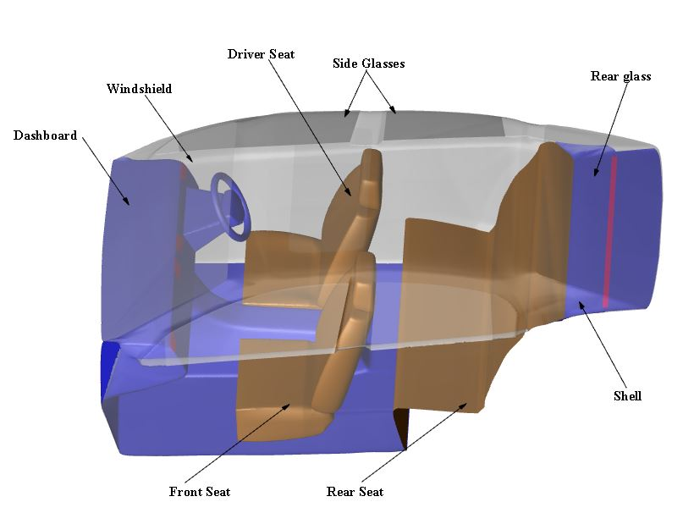The car environment can be defined with six thermal comfort factors such as air temperature, air velocity, air humidity, mean radiant temperature, human activity level and clothing insulation. All these factors are independent but together they contribute to establish thermal comfort. It is difficult to measure all parameters in the exact same location [literature_review paper]. However, there is one simplified way to quantify the feeling of thermal comfort using Air Diffusion Performance Index (ADPI). Studies have been attempted to access thermal comfort in passenger compartment of a train coach using Air Diffusion Performance Index (ADPI). Effective Draft Temperature (EDT) which is used for the calculation of ADPI has been a popular tool for evaluating the performance of mixing ventilation system [4]. The application of EDT has never been extended for automobile cabins. Hence, the present study is an attempt to extend the application of EDT to automobile cabin by comparing is made between EDT and ET at different body points. In addition, the sensitivity of the vehicle thermal environment affecting thermal comfort, including the airflow direction was highlighted

2. Numerical Simulation

2.1. Governing Equations

Flow inside the computational domain is considered to be three dimensional, unsteady, incompressible and turbulent. The following governing equations for continuity, momentum and energy were used.

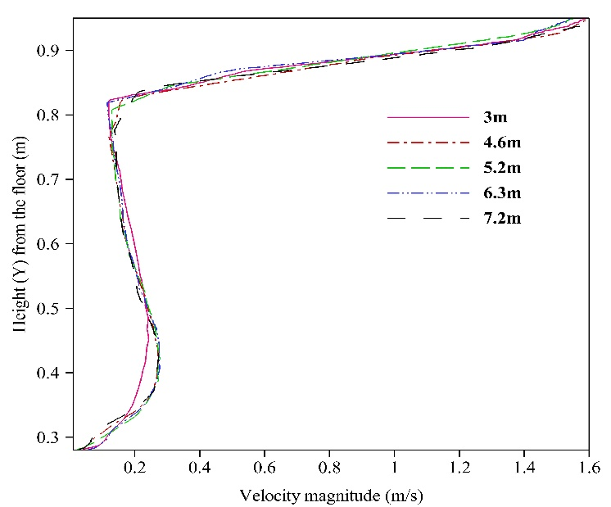 $\frac{∂ρ}{∂t}+\vec{∇}⋅\left(ρ\vec{v}\right)$ = *Sm* (1)

$\frac{∂\left(ρ\vec{v}\right)}{∂t}+\vec{∇}⋅\left(ρ\vec{v}\vec{v}\right)=-∇p+∇⋅\left(\overline{τ}\right)+ρ\vec{g}+\vec{F}$ (2)

$\frac{∂(ρE)}{∂t}+ ∇∙\left(\vec{u} \left(ρE+p\right)\right)= ∇∙\left(k_{eff}∇T-\left(\sum_{j}{h_{j}J_{j}+ {\overset{̿}{τ}}_{eff}}∙\vec{u}\right)\right)+ S_{h}$ (3)

Where $S_{m}$ is the mass source, $\vec{v}$ is the velocity vector, p is the static pressure, $\overset{̿}{τ}$ is the stress tensor, $ρ\vec{g}$ and F are the gravitational body force and external body forces. $k_{eff}$ is the effective conductivity (*k* + $k_{t}$ where $k_{t}$ is the turbulent thermal conductivity, defined according to the turbulent model being used), $J_{j}$ is the diffusion species and $S_{h}$ includes the heat of the chemical reaction and other volumetric heat source.

RNG k-e model was chosen for the turbulence modelling in the numerical simulation. This model has been found most appropriate based on convergence and computational stability criteria. The computational results are in good agreement with those obtained from the experiments [5].

2.2. Geometry Modelling

A typical medium-sized passenger car was chosen for the present study. Dimension of the model was exactly same as that of actual model. The model was simplified and only those parts which are relevant for analyzing the flow physics are considered for this study to reduce the computational cost and Fig. 1 shows the computational domain considered for the analysis. As the geometry of the car cabin is very complex, triangular elements were used for the surface of the passenger compartment and tetrahedral cells for the volume region. Grid is generated with the help of commercial software ANSYS ICEM 18.1. The total glazing surface area is estimated to be 2.5 m2 and the total estimated interior volume of the passenger compartment is 2.3 m3.

Figure 1 Figure caption

A rigorous grid independence tests was performed by observing the numerical solution for the velocity field near the central diffuser, for different grid sizes. System with 4.6 million cells was adopted as the velocity profile suggested that the results were grid-independent when the number of cells exceeded 4.6 million as shown in Fig. 2

Figure 2 Figure caption

2.3. Numerical Details and Solar Load

The most vital input in this analysis is solar load acting on the cabin. The solar load depends on the properties of the glass, the solar angle of incidence. The windshield, side windows and rear window were treated optically as semi-transparent walls. For the present study all the glass surfaces in the passenger compartment have transmissivity of 80% and absorptivity of 10%. The solar load model in ANSYS-Fluent 18.1 is used to calculate radiation effect 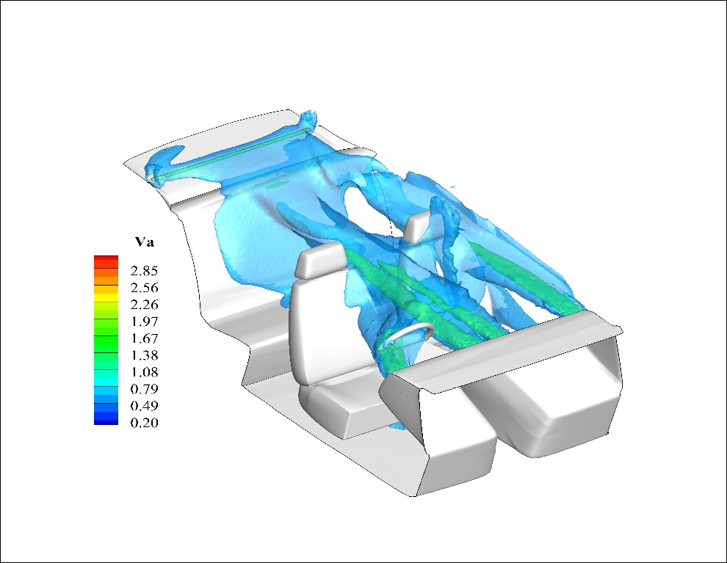of the sun rays entering the computational domain. It accounts for both direct as well as diffused radiation. The location of sun was simulated for 21st April 12:00 PM IST. Surface to Surface (S2S) radiation model was employed to mimic radiation heat transfer between interior surfaces of the cabin.

The absolute convergence criteria for mass, momentum and energy equations were chosen to be 10-3, 10-3 and 10-6 respectively. The exterior air temperature was set at constant value of 30oC. Combined external radiation and convection boundary condition was given to the outer shell and glass surfaces of the cabin. Vehicle was assumed to be in the parked condition. Convective heat transfer coefficient for the outer surfaces was determined using Eq. 4

$h_{c}=1.163(4+12\sqrt{v})$ (4)

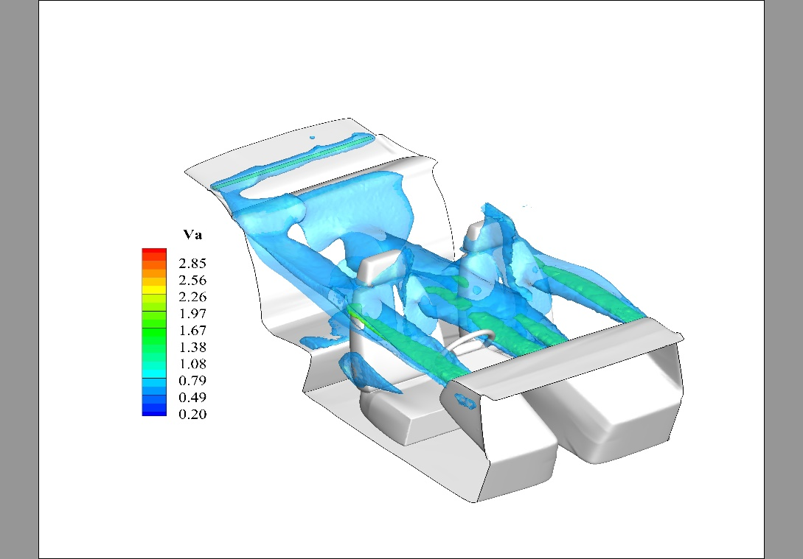Where, *hc* is convective heat transfer coefficient and *v* is air velocity. Based on the Eq. 4, *hc* was estimated to be 15W/m2-K. The pressure outlet boundary condition was imposed on A/C outlet vent with pressure equals to atmospheric pressure of 101.3kPa. No-slip boundary conditions were imposed at the wall surfaces of windshield, side glasses, rear window, dashboard, seats and floor. Total flow time was set as 1800s with time-step size of 1s for the numerical simulation. The supply air temperature was set at 9oC. The initial air temperature inside the cabin was set to 50oC. Constant supply air velocity of 3.27m/s was considered throughout the transient simulation. For the right-side air vent, different vertical guide vane angles in the horizontal plane were considered ranging from 0o to 30o. Fig. 3 and Fig.4 shows the iso-values of the velocity magnitude corresponding to the two extreme angles. Same flow rate was maintained for all cases.

Figure 3 Figure caption

Figure 4 Figure caption

2.4. Validation of Numerical Model

Results from three-dimensional transient simulation were validated with those obtained from experimental data from Sevilgen and Kilic [6] shown in Fig. 3. Similar boundary conditions were imposed on the present numerical model as mentioned by Sevilgen and Kilic.

The maximum difference between numerical solution and experiments was 2oC showing suitable agreement between predicted and experimental results. The difference between results can be explained by different orientation of diffusors, geometry of the cabin which is not exactly identical in experiment and simulation.

Figure 5 Figure caption

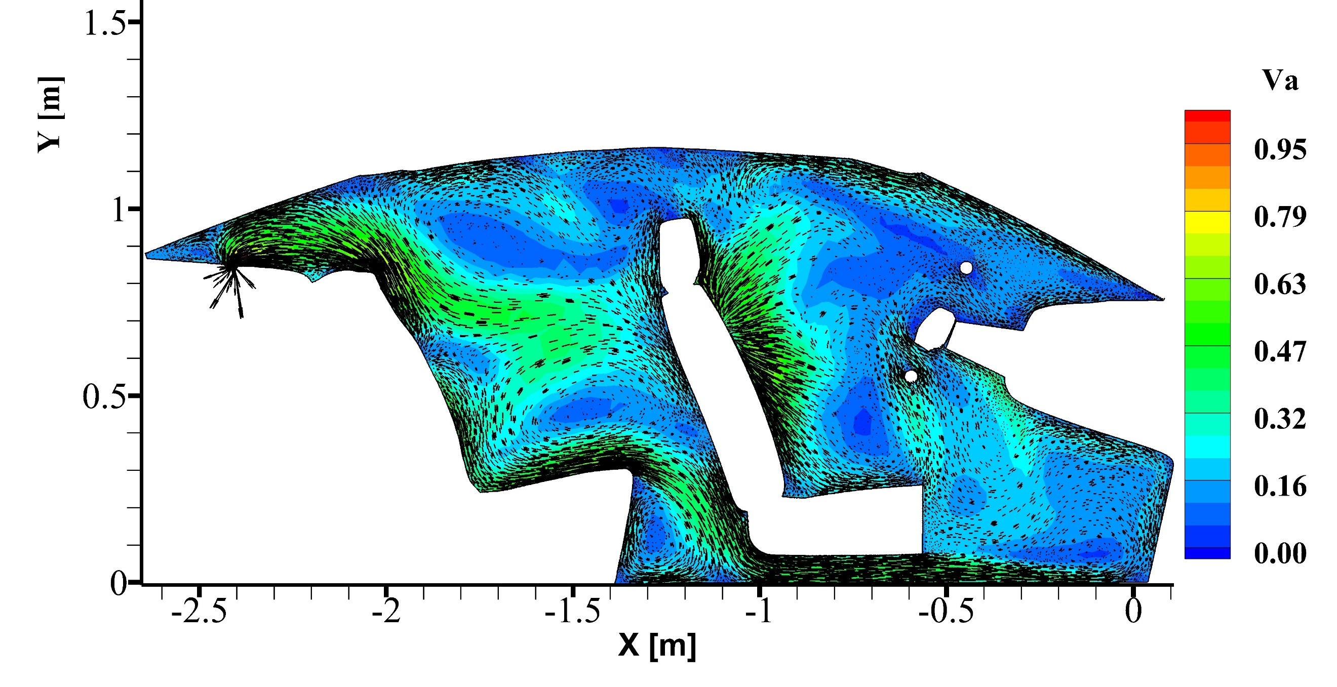3. Thermal Comfort Analysis

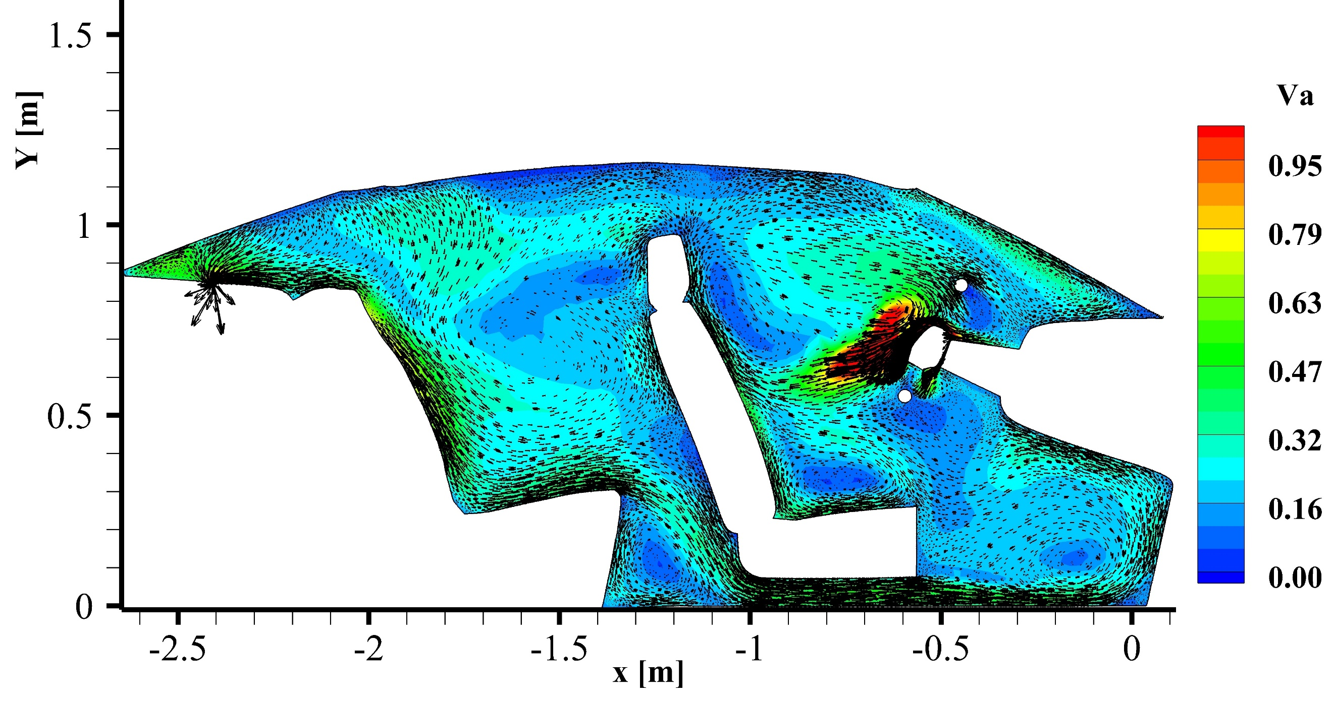The present study considers two different techniques for the evaluation of thermal comfort on the basis of CFD results. The ET model, which is widely used for predicting thermal comfort of the passenger in the automobile cabin can evaluate thermal comfort for various body parts.

$ET=\left\{\begin{aligned}0.5×\left(T_{a}+ T_{r}\right) , &v_{a}<0.1m/s \\ 0.55T_{a}+0.45T_{r}+ \frac{0.24-0.75\sqrt{v_{a}}}{1+ I_{cl}}(36.5- T_{a}), &v_{a}≥0.1 m/s\end{aligned}\right.$

(5)

$Tr=\left(\left(\sum_{n}{F_{p-i}×\left(Ti+273\right)}\right)\right)-273$ (6)

The asymmetric thermal condition in a vehicle compartment, makes the determination of local ET values particularly useful. The zones from 1 - 5 represent the range related to thermal sensation: 1 - too cold, 2 - cold but comfortable, 3 - neutral, 4 - warm but comfortable and 5 - too hot and this range indicates thermally acceptable levels for various body parts.

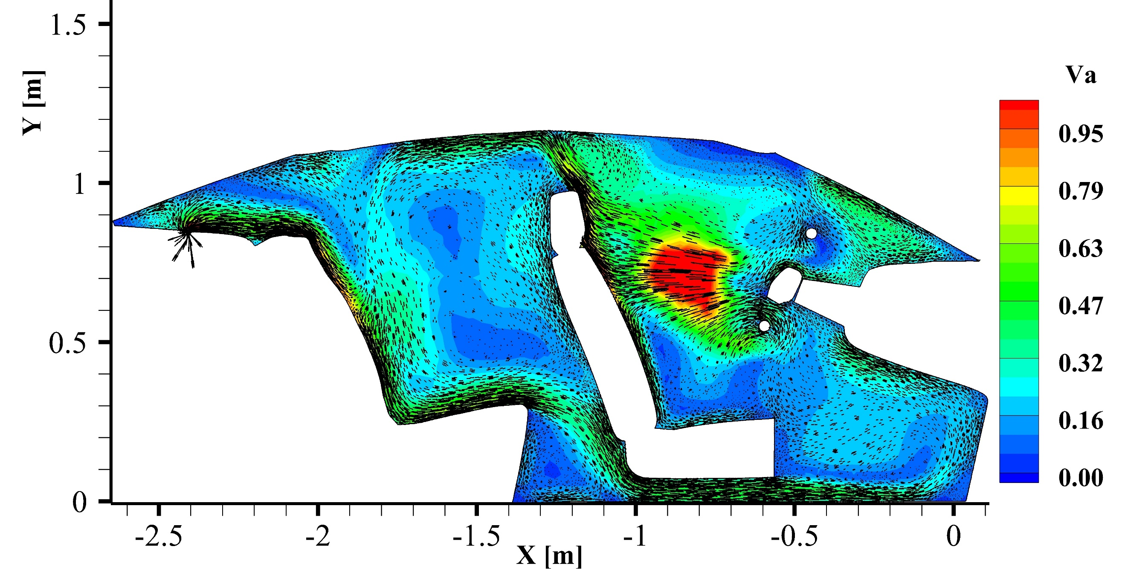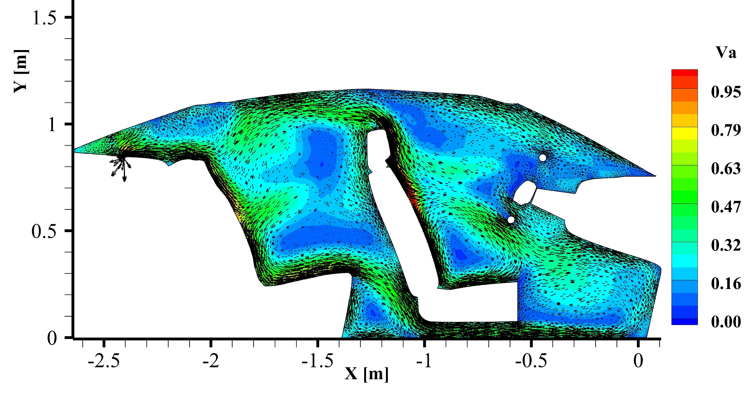EDT is a calculated temperature difference that combines air temperature and air speed. EDT quantifies the deviation of local air temperature from room control temperature and air speed in the occupied zone, it relates to thermal comfort. As it has been already discussed that there are various parameters required to evaluate ET such as MRT, clothing insulation, air temperature and air velocity which is difficult to evaluate all at the same point. EDT provides an easier way which only requires air temperature and air velocity. The following equation was used to define EDT:

$EDT=\left(T_{x}- T_{c}\right)-0.1276(v-0.15)$ (7)

Where $T_{x}$ is the local airstream dry-bulb temperature (oC), is the average (control) room dry-bulb temperature (oC) and *v* is the local airstream velocity (m/s). Standard limits have been established for acceptable EDT. Variation from accepted range causes discomfort to the occupant. Occupant comfort can be ensured if the EDT values lie between -1.7oC to 1.1oC, if the values are higher than 1.1oC implies hot zone and values below -1.7oC are considered as cold zone.

4. Results and Discussion

Distribution of velocity magnitude and of the in-plane vectors for the median plane of driver has been shown in Fig. 6. One can easily observe that there is significant change in the over-all pattern of the flow as the direction of flow changes at driver side air vent. Starting with an angle 20o in the front region, velocity magnitude values at the driver’s chest region are higher than 1m/s. In the region of face and chest for the rear right passenger the velocity magnitude displays over 0.5 m/s. In the case with angle 0o velocity magnitude values are in the range of 0.3 - 0.6 m/s for the face and chest region of driver and rear right passenger. Similar observation can be made for the case with the angle of 30o where the velocity magnitude values in the chest and head region of driver and rear right passenger are in the range of 0.3 - 0.4 m/s. A completely different

Figure 6 Figure caption

scenario was observed for the case with the air flow direction normal to the surface of dashboard Fig 5(e). From the figure it is evident that there is almost negligible air movement in the front region of the compartment where the velocity magnitude values at chest and head region are in the range of 0.01 - 0.16 m/s, whereas in the rear region the velocity magnitude values are in the range of 0.3 - 0.6 m/s.

EDT contours at the median plane of driver for different flow directions have been shown in Fig. 7. Starting with the 0o angle EDT values are in the comfort range at the face and chest level. With the increase in angle one can observe that the EDT values in the driver region are shifting towards the hot zone.

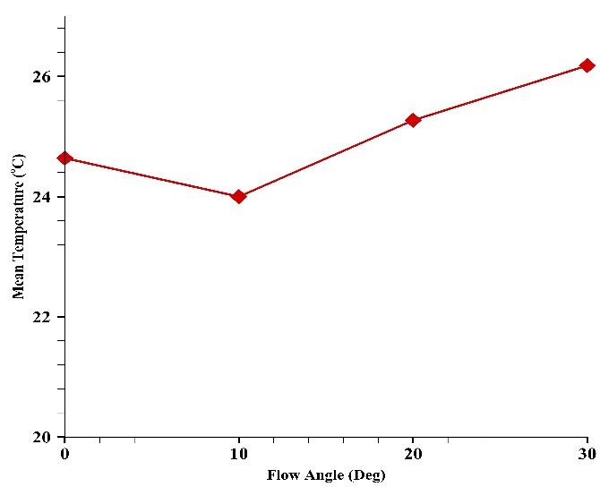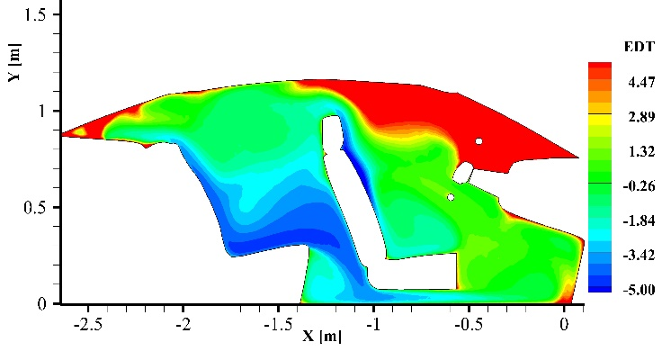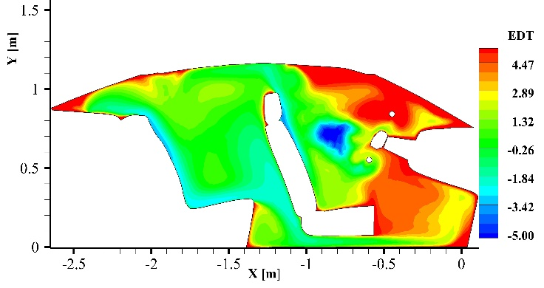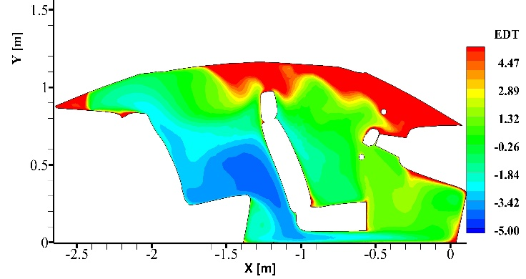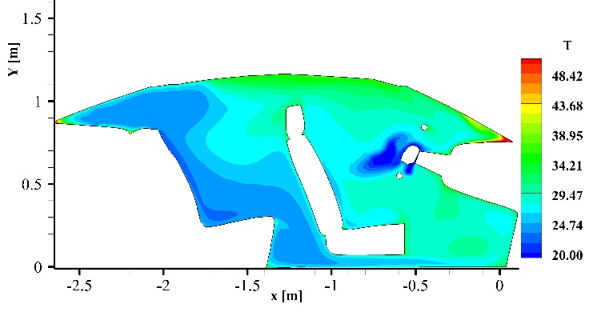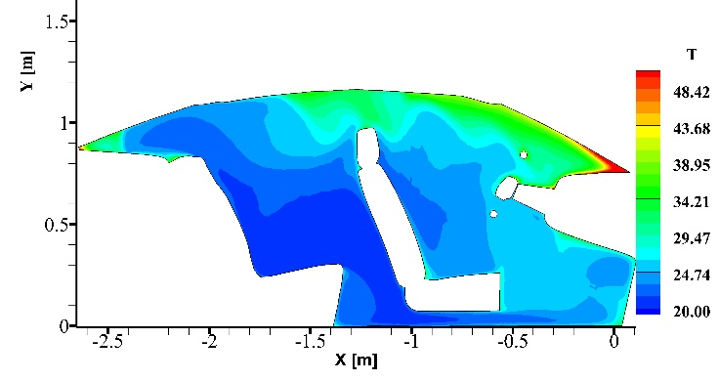Figure 7 Figure caption

Figure 8 Figure caption

It is evident from Fig. 7 that changing the flow direction can have an impact on the bulk mean temperature. Even though the variation is in the range of 2oC, it does change the overall temperature distribution. Fig. 8 explains how temperature in the driver’s median plane is varying as the flow angle increases. Rise in temperature at the front driver region as well as rear passenger region has been observed. Although temperature in the passenger region is still lower than front region. It was also observed from Fig. 3 and Fig 4, that most of the air flow is directed towards the back due to the high velocity of cold air stream from the vent.

Figure 9 Figure caption

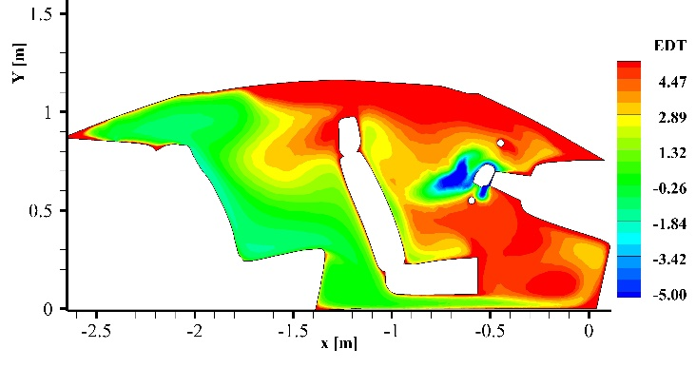Whereas completely opposite phenomenon is observed for the rear right passenger, starting with 0o angle EDT values in the rear right passenger region are in cold zones but on changing the angles the EDT values are shifting towards the comfort zone. Since calculation of EDT involves temperature and velocity, it evident from the velocity contours in Fig. 6 that the flow in the driver region is getting weaker as the flow direction changes, and since the flow is weak which implies that there is weaker circulation of cold air from the vents therefore the temperature rise was higher in the front region and because of which higher values of EDT in the driver region have been observed. For the rear passenger, since the entire flow of cold air from the vents was directed towards the rear side irrespective of any case, and then it recirculates in the entire cabin, therefore, temperature values close to the average room control temperature and higher values of velocity magnitude in the rear region were observed which causes shift in the EDT values towards the comfort zone.

5. Conclusion

Type the contents of the conclusion here, type the contents of the conclusion here. type the contents of the conclusion here. type the contents of the conclusion here. type the contents of the conclusion here. type the contents of the conclusion here. type the contents of the conclus’

ion here. type the contents of the conclusion here. type the contents of the conclusion here. type the contents of the conclusion here. type the contents of the conclusion here.

References

[1] Understanding pattern of work travel

[2] Schafer, A., “Long-Term Trends in Global Passenger  
Mobility”, Frontiers of Engineering: Reports on Leading-Edge Engineering from the 2006 Symposium. TheNational Academies Press, Washington, DC, 2007. ISBN 978-0-309-10339-8

[3] Norin, F. and Wyon, D.P., 1992. “Driver vigilance-the  
effects of compartment temperature” (No. 920168). SAETechnical Paper

[4] Lin, Z., 2011. “Effective draft temperature for evaluating  
the performance of stratum ventilation.” Building andenvironment, 46(9), pp.1843-1850

[5] Posner, J.D., Buchanan, C.R. and Dunn-Rankin, D., 2003.  
“Measurement and prediction of indoor air flow in a  
model room.” Energy and buildings, 35(5), pp.515-526.

[6] Sevilgen, G. and Kilic, M., 2013. “INVESTIGATION OF TRANSIENT COOLING OF AN AUTOMOBILE  
CABIN WITH A VIRTUAL MANIKIN UNDER  
SOLAR RADIATION.” Thermal science, 17(2).

Acknowledgement

Thank you.